**Use decision trees to prepare a model on fraud data**

**treating those who have taxable_income <= 30000 as "Risky" and others are "Good"**

**Ans:**

> Fraud_check <- read_csv("C:/Users/Dell/Desktop/ExcelR Assignments/11. Decision Tree/Fraud_check.csv")

> head(Fraud_check)

# A tibble: 6 x 6

Undergrad Marital.Status Taxable.Income City.Population Work.Experience Urban

<chr> <chr> <dbl> <dbl> <dbl> <chr>

1 NO Single 68833 50047 10 YES

2 YES Divorced 33700 134075 18 YES

3 NO Married 36925 160205 30 YES

4 YES Single 50190 193264 15 YES

5 NO Married 81002 27533 28 NO

6 NO Divorced 33329 116382 0 NO

**As per problem statement, treating those who have taxable_income <= 30000 as "Risky" and others are "Good"**

> Fraud_check$Taxable.Income <- ifelse(Fraud_check$Taxable.Income <=30000, yes = "Risky", no = "Good" )

> table(Fraud_check$Taxable.Income)

Good Risky

476 124

> str(Fraud_check)

Classes ‘spec_tbl_df’, ‘tbl_df’, ‘tbl’ and 'data.frame': 600 obs. of 6 variables:

$ Undergrad : chr "NO" "YES" "NO" "YES" ...

$ Marital.Status : chr "Single" "Divorced" "Married" "Single" ...

$ Taxable.Income : chr "Good" "Good" "Good" "Good" ...

$ City.Population: num 50047 134075 160205 193264 27533 ...

$ Work.Experience: num 10 18 30 15 28 0 8 3 12 4 ...

$ Urban : chr "YES" "YES" "YES" "YES" ...

**Converting into dummy variables for chr columns.**

> Fraud_check$Undergrad <- ifelse(Fraud_check$Undergrad=='YES',1,0)

> Fraud_check$Urban <- ifelse(Fraud_check$Urban=='YES',1,0)

> MS_single <- ifelse(Fraud_check$Marital.Status=="Single",1,0)

> MS_divorced <- ifelse(Fraud_check$Marital.Status=="Divorced",1,0)

> MS_married <- ifelse(Fraud_check$Marital.Status=="Married",1,0)

> Fr_check <- Fraud_check

> Fr_check <- cbind(Fr_check,MS_married,MS_single,MS_divorced)

**Build model using Party Library**

> library(party)

> fc_tree1 <- ctree(Fr_check$Taxable.Income ~. , data = Fr_check)

> plot(fc_tree1)

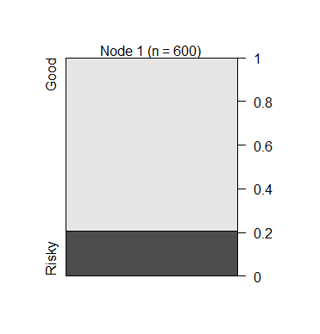

**Build model using tree Library**

> library(tree)

> fc_tree <- tree(Fraud_check$Taxable.Income ~. , data = Fraud_check)

Warning messages:

1: In tree(Fraud_check$Taxable.Income ~ ., data = Fraud_check) :

NAs introduced by coercion

2: In tree(Fraud_check$Taxable.Income ~ ., data = Fraud_check) :

NAs introduced by coercion

> plot(fc_tree)

Error in plot.tree(fc_tree) : cannot plot singlenode tree

**Build model using C50 Library**

> library(C50)

> fc_tree2 <- C5.0(Fr_check[,-2],Fr_check$Taxable.Income)

> plot(fc_tree2)

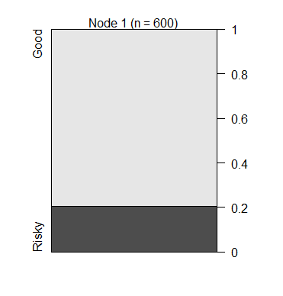

**Build model using rpart Library**

> library(rpart)

> fc_tree3<- rpart(Fr_check$Taxable.Income ~.,data= Fr_check, method = 'anova')

> plot(fc_tree3)

Error in plot.rpart(fc_tree3) : fit is not a tree, just a root

As we can see from above 4 models, Due to lack of relevant information in data set we can conclude that unless and until a relevant variable is not introduced with this data, it won’t perform well. All the classification will be biased to one side.